Optimizing Small-Scale Rocket Engine Performance: Comparative Analysis of Nozzle Geometries and Their Commercial Applications

Word Count: 4667

At the highest level of aerospace engineering, rocket propulsion technology has fueled advances in science, satellite location, and space studies. At its core sits the all-important component of rocket engines, called the rocket nozzle. It is a deceptively simple but incredibly complex device that is crucial in the transfer of thermal energy to directional thrust. Rocket nozzle shape is an important engineering consideration that can affect the overall performance, efficiency, and capability of an engine. Rocket nozzle design is a difficult problem for engineers due to optimization. The main purpose of a nozzle is to speed up exhaust gases to generate thrust. It may sound easy, but doing this in reality is anything but simple. Different nozzle geometries can produce very different thrust characteristics depending on many variables such as expansion ratio, throat diameter, and exit cone angle. The research in my paper explores connections between rocket nozzle geometries and their influence on thrust creation using an experimental approach. Through research and comparison of different nozzle designs under a controlled environment, through the use of a simulator, I aim to provide raw data on performance differences due to different nozzle designs
The literature review will give context to my research while also explaining advancements and possible future directions. It will go over historical advancements, theoretical context, and previous experimental findings in rocket nozzle design. This research is of practical importance beyond the realm of just academics. If we improve our understanding of nozzle geometry, it can yield more efficient rocket engines, and therefore potentially reduce fuel consumption, increase payload capacity, and make space flights more economical.
History and Evolution of Rocket Engines
Many people think that NASA must have created rocket engines for the first time during the space race in the 1960s. That isn't the case, though. In his book "Fundamentals of Rocket Propulsion," D.P. Mishra claims that the Chinese had created the first rocket engine almost a millenia ago. He states, “The real rocket was invented by the Chinese around the tenth century AD while experimenting with gunpowder and bamboo.” This seemingly simple beginning signaled the start of a technological revolution that would eventually revolutionize human propulsion and exploration capabilities.
Ever since the Chinese invented what was later known as the firework, the development of rocket technology continued to evolve rapidly. "Around the thirteenth century, rockets were used as bombardment weapons even in Western countries like Spain and was generally brought by the Arabs and Mongol hordes," states Mishra. What began as a localized innovation quickly became a tool of strategic military significance, spreading across continents and cultures.
Reaching the 20th century, the pace of rocket engine development accelerated dramatically during global conflicts. "During the First World War, the work on rocket engines was expedited by various countries to win the war,” states Howard W. Douglas in his research paper, Liquid Rocket Engine Nozzles. This period of intense research and development marked a critical turning point in understanding and refining rocket propulsion technologies.
A significant technological challenge emerged during this evolutionary process. "During this period, it was found that solid propellants are difficult to handle and hence scientists across the globe started serious experiments for developing liquid fuel–fired rocket engines," Douglas states. This recognition of solid propellants' limitations drove scientific innovation, pushing researchers to explore more sophisticated propulsion methods.
Each of these historical moments represents a crucial step in the progression of rocket engine technology. From the accidental discoveries of Chinese inventors experimenting with gunpowder to the strategic developments of wartime researchers, the history of rocket engines reflects humanity's persistent drive to push technological boundaries.
Understanding history gives us context. However, to understand what exactly a rocket engine is and how it functions on a basic level, having a basic understanding of some of the basic scientific principles that make rocket propulsion possible is paramount.

Basic Rocket Science Principles
"A typical rocket motor consists of the combustion chamber, the nozzle, and the injector," states RocketLab. These three critical components form the core architectural framework of rocket engine design, each playing a crucial role in the complex process of generating thrust.
The operational mechanism of a rocket engine reveals remarkable engineering precision. "A liquid rocket engine employs liquid propellants which are fed under pressure from tanks into a combustion chamber." This systematic approach to propellant management allows for controlled and efficient energy conversion.
Central to understanding rocket propulsion is the concept of thrust generation. "The thrust force of a rocket motor is the reaction experienced by the motor structure due to the ejection of the high-velocity matter." This fundamental principle, rooted in Newton's third law of motion, explains how rocket engines create directional movement by expelling matter at high speeds.
Key performance metrics provide deeper insights into rocket engine efficiency. Specific impulse emerges as a critical parameter, defined mathematically as "the thrust developed per weight unit (newton) of total propellant burned per second." Calculated by dividing thrust by the total propellant weight flow rate, specific impulse is expressed in units of kg/s, offering a standardized measure of a rocket engine's performance capabilities.
Another crucial concept in rocket engine design is the mixture ratio. Defined as "the weight flow of oxidizer divided by the weight flow of fuel" (O/F) by RocketLab, this ratio represents the precise balance of oxidizer and fuel components. The mixture ratio significantly influences combustion efficiency, engine performance, and overall propulsion system effectiveness.
These fundamental principles demonstrate the intricate scientific and engineering considerations that underpin rocket propulsion technology. From precise component design to sophisticated performance metrics, rocket engine development represents a complex interplay of physics, thermodynamics, and mechanical engineering.
Rocket Engine Nozzle Overview and Concepts
The rocket nozzle is far more than a simple exhaust pipe. It represents a critical engineering component designed to transform thermal energy into directional kinetic energy. In essence, the nozzle carefully shapes and accelerates exhaust gases to convert the intense heat of combustion into a powerful forward thrust that propels the rocket vehicle.
NASA states, "In general, the nozzle shape is selected to maximize performance within the constraints placed on the system.” This principle underscores the nuanced approach to nozzle design, where engineers must balance multiple factors to optimize rocket performance. The complexity of nozzle design extends beyond simple geometric considerations, requiring a deep understanding of thermodynamics, fluid mechanics, and material science.
Calculating the nozzle throat cross-sectional area represents a sophisticated engineering challenge that involves understanding several key variables. “Engineers must carefully analyze total propellant flow rate, specific propellant characteristics, operating conditions, gas temperature, and pressure,” as stated by USC professor John Targonski. The fundamental equation for determining nozzle throat area can be expressed as: A = (ṁ * √(R * T)) / (P * √(γ)). Where: A = Nozzle throat cross-sectional area ṁ = Mass flow rate R = Gas constant, T = Temperature P = Pressure, γ (gamma) = Specific heat ratio.
A fundamental insight into nozzle thermodynamics reveals an interesting occurrence related to temperature distribution. The temperature at the nozzle throat (Tt) is always lower than in the combustion chamber. This temperature reduction occurs because thermal energy is converted into the kinetic energy needed to accelerate gases to achieve thrust.
The equation that represents the nozzle throat temperature is: Tt = Tc [1 / (1 + (γ-1)/2)]. Where: Tt = Temperature at the nozzle throat, Tc = Combustion chamber temperature, γ = Specific heat ratio.
The calculations highlight the advanced engineering applied to what might otherwise appear to be a simple part of a rocket. The nozzle exists as a sophisticated piece of equipment for converting energy, carefully designed to maximize the rocket's propulsive effectiveness.
Gap Identification
With most of the study concentrated on orbital launch vehicles, satellite propulsion, and aerospace applications demanding very high performance, the field of rocket propulsion has seen significant developments in the creation of large-scale engines. But small-scale rocket engines are still poorly understood. Though many studies have thoroughly examined the performance traits of big rocket engines, the small-scale rocket propulsion phenomena have, to a large extent, gone unexplored.

The aim of the present research is to fill this important knowledge gap with an in-depth analysis of the performance characteristics of small-scale rocket engines. The interest in miniature propulsion systems is more than academic curiosity; instead, it reflects the response to the growing technological challenges in many areas. These applications include the launching of micro-satellites and scientific research probes, and the development of aerial vehicle technology and precision engineering.
The limited amount of research in the area of small-scale rocket propulsion faces numerous important challenges. The most common literature in the field is based on the miniaturization of large-engine designs rather than the development of specialized solutions specifically for small-scale propulsion. Such an approach neglects the thermodynamic, fluid dynamic, and geometric constraints appearing at smaller scales. In particular, nozzle geometry is one of the key parameters that can be much more complicated when working with small dimensions.
Research Method
Moving on to the research method, I used an experimental research method for this study to determine the thrust and efficiency of various rocket engine nozzle geometries. Initially, my goal was to build a physical experimental model of a small rocket engine and perform tests to gather first-hand data. This approach would have enabled precise measurements and real-world validation of theoretical predictions. However, due to safety concerns and institutional restrictions, the school research board did not approve my proposal. Given this limitation, I adapted my methodology using a simulation-based experimental approach. While this alternative was not as definitive as a physical experiment, it provided an ideal testing environment where variables could be accurately controlled, ensuring consistent and repeatable results. Using computational simulations, I could assess the performance of different nozzle geometries without the constraints posed by physical testing, such as material limitations, manufacturing errors, or external environmental factors.
The data collection process began with identifying the specific parameters necessary for evaluating nozzle efficiency and thrust performance. These variables included thrust output over time, the mass of the engine, fuel type and combustion characteristics, nozzle geometry and its influence on exhaust expansion, and the engine's material properties. Once these key data points were established, I selected simulation software capable of accurately modeling rocket engine performance. The chosen simulator, HalfCat Simulator or “HalfCat”, allowed me to configure multiple variables, enabling me to conduct tests in controlled and repeatable conditions.
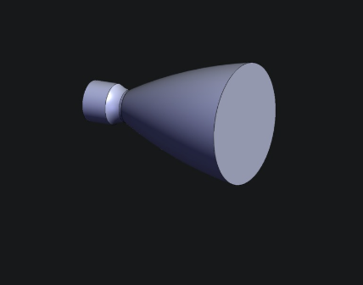
Before running simulations, I developed 3D CAD models of the rocket engines to ensure an accurate representation of their geometry, which is the dimensions and specifications of the engine, such as throat diameter and nozzle opening diameter.

This is one of the most common types of rocket nozzles. This is a bell-shaped rocket nozzle, and it is the nozzle that is most common in rocket engine design. It was the same type of nozzle design used on the Saturn V rocket, as well as the SLS system.
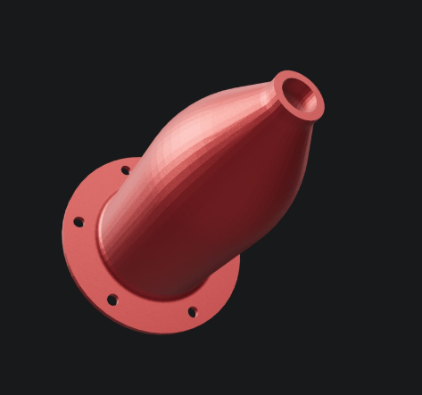
This is the 3d model for a conical-shaped Rocket engine. The small opening is the area where exhaust gases are expelled. In a conical rocket engine, there does not need to be a large “cone” at the end.

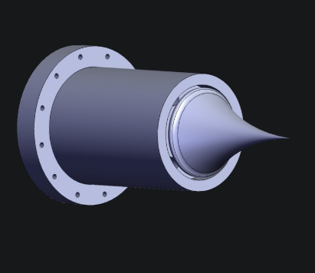

This is an Aerospike nozzle. This is the most complex of the three nozzles that I have chosen to study, and are usually not used in large-scale rocket engines, due to their complexity.

Later on, the above-mentioned models were implemented within the simulation software as a basis for assessing thrust performance. With the inclusion of key variables like combustion chamber pressure, temperature, and exhaust speed, the simulator produced thrust curve plots that illustrated the performance of each nozzle geometry over a period of time. The experiment used three different nozzle geometries under a comprehensive comparative analysis. For maximizing the reliability of the results, each simulation was run multiple times considering the variability of the results from the computation.
The data obtained were analyzed using both quantitative and comparative methods to determine the geometry of the nozzle having the maximum efficiency. The main analysis was a comparison of the thrust curve plots of each nozzle configuration. By comparing the maximum thrust values with the general trends within each plot, I was able to determine the nozzle geometry producing the maximum thrust. This analysis provided some initial observations regarding the differences in performance between the different designs.
Although maximum thrust was a very crucial factor, efficiency as a whole turned out to be the more central factor in determining the best nozzle configuration. Efficiency was considered based on several factors including the thrust-to-weight ratio as the ratio of the thrust produced by the engine and the weight of the engine, fuel utilization efficiency as a measure of the effectiveness with which fuel was burned and expanded via the nozzle, and specific impulse as a measure of the thrust effectiveness over the exhaust velocity as well as the fuel flow. Quantification of these parameters required the application of engineering equations as well as computational software on the raw simulation results. The process needed manual computation of specific values like the exhaust velocity and mass flow rate, as well as comparison of different nozzle configurations.
Though the simulation-based approach returned accurate and consistent results, it came with several inherent limitations. The first disadvantage was related to the lack of validation concerning real-world scenarios. Since the experiments were conducted in an ideally optimized simulated world, externalities in the form of atmospheric pressure fluctuations, material degradation, and the possible degradation of the engine were not accounted for in the analysis. In addition, the software used mathematical models to predict engine performance, which meant that real-world anomalies and unexpected variables were not accounted for in the results. Also, since opportunities for building and testing a physical prototype were limited, my results are purely computational model-based as opposed to empirical research.
Despite these limitations, the controlled environment of the simulations allowed for consistency across the experimental trials, thus making meaningful comparisons between different nozzle geometries possible. The approach taken allowed for a close examination of a multitude of designs and provided a solid basis for determining the most optimal nozzle configuration for rocket engine performance improvement. In summary, my study took a simulation-based route due to institutional constraints. Through the combination of 3D CAD modeling and computational simulations, I was able to obtain accurate data specific to thrust efficiency and thrust performance for a series of nozzle geometries. The analysis of the data included comparative and mathematical analysis against the most optimal design. While the lack of empirical verification placed some constraints, the methodology outlined in this research was shown to be an effective method of developing knowledge relating to nozzle efficiency and thrust maximization and hence a suitable alternative to traditional physical testing.

The first step was to collect the raw data created by the HalfCat Simulator for each unique nozzle geometry. There were thrust values, pressure within the combustion chamber, exhaust velocity measures, and mass flow rates. To enable comparisons, I organized these sets of data into graphical displays, thus permitting the explicit assessment of the performance characteristics of the three nozzle geometries and the ability to look for patterns and inconsistencies.
In line with the structure of the initial data, statistical analysis software was utilized to normalize the results and minimize computational variations between simulation runs. The approach involved calculating mean values for key parameters over several iterations and establishing standard deviations to assess the reliability of the results. The normalization process allowed for the verification that the data used in comparing the different nozzle geometries was reliable, rather than being subjected to inherent anomalies relating to the simulations.
The next phase of my research focused on creating a graphical representation of the data through thrust curve graphs. These graphs plotted the thrust output against time, thus enabling an easy visualization of the performance profiles of each nozzle. I also created separate visual representations of the specific impulse values and exhaust velocity distributions at the nozzle exit areas. This helped to improve my understanding of the flow characteristics relevant to each design.
To make strides beyond simple visual evaluation, mathematical formulas were used to calculate necessary performance parameters. The thrust-to-weight ratio was determined by calculating the maximum thrust produced divided by the weight of the engine, providing a useful indicator of each model's overall effectiveness. Additionally, specific impulse values were calculated as the thrust divided by propellant mass flow rate, thus providing a quantifiable measure of propulsion effectiveness that allows for objective comparison.
The final stage of the analysis consisted of a comprehensive analysis of the performance measures with the geometric attributes of individual nozzles. By the use of correlation analysis, the dimensional parameters that directly influenced the performance variability were determined, thus creating a nozzle geometry thrust efficiency relationship.
Key Findings
The results of the analysis reported significant differences among the three nozzle geometries considered. The conical rocket nozzle had stable performance with a mass flow rate of 0.701 kg/s, exit Mach number of 0.6, exit temperature of 1600 K (2420°F), exit pressure of 303 psi, and exit velocity of 230 m/s (514 mph). The total efficiency of this nozzle configuration was 61% and produced a thrust of 191 lbf. In addition, the nozzle provided a consistent thrust output whereby the fluctuation decreased as the chamber pressure decreased over time.
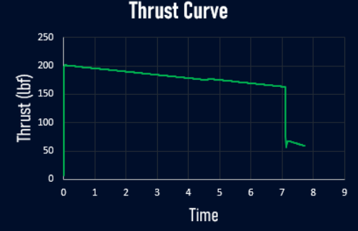

This is the thrust performance graph for the Conical rocket nozzle. (Halfcat)

The bell-rocket nozzle configuration had better metrics of performance, including a mass flow of 0.844 kg/s, an exit Mach number of 0.95, and an exit temperature of 1830 K (2830°F). Chamber pressure was 181 psi, and the exit velocity was a recorded 325 m/s (727 mph). The design had a satisfactory efficiency rating of 79% and a maximum thrust of 297 pounds. However, the design was revealed to have significant thrust oscillations, especially during the initial stages of combustion.

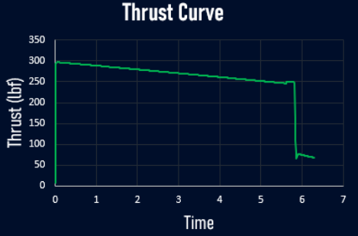

This is the thrust performance graph for the bell-shaped rocket nozzle. (HalfCat)

Aerospike Rocket Nozzle produced satisfactory performance as evidenced by a mass flow of 0.861 kg/s, exit Mach number of 0.81, exit temperature of 1740 K (2672°F), chamber pressure of 165 psi, and exit velocity of 275 m/s (615 mph). The design achieved a rating of 60% of efficiency as it produced 221 lbf of thrust. Notably, the nozzle recorded the highest level of stability in thrust profile with minimal or zero oscillation throughout.
The results from my data showed a substantial correlation between nozzle expansion ratio and specific impulse, which continued to a point of diminishing returns beyond a certain point. This means that there is an ideal expansion ratio for small-scale engines in standard atmospheric conditions, beyond which any improvements are negligible when compared to the added complexities of manufacture and the requirements for materials.

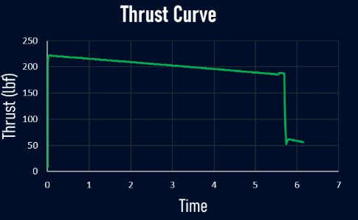

This is the thrust performance graph for the Aerospike rocket nozzle.

An additional key observation involves the nozzle geometry's role in the features of the exhaust flow. The bell nozzle configuration had better flow attachment when compared to the conical nozzle shape and produced a higher level of exhaust expansion and a resultant boost in thrust output. The simulation analysis indicated the bell nozzle was more sensitive towards changes in the operational conditions, thus explaining the significant thrust oscillations that existed during the experiment evaluations.

Discussion/Analysis
By putting those values into the equation for thrust that was stated in the literature review section, I was able to double check the values that were given by the simulator. Overall, the numbers that I got for thrust performance and efficacy match up within acceptable tolerances. These differences in performance among different nozzle geometries can be traced back to the fundamentals of fluid dynamics. One of the main parameters to influence the production of thrust is the ability of the nozzle to efficiently convert the thermal energy produced by combustion into the kinetic energy of the existing gases. Energy conversion depends considerably on the expansion ratio as well as the nozzle profile geometry.
The increased effectiveness of the bell-shaped rocket nozzle results from the ideal expansion ratio achieved under optimized environmental conditions. The nozzle's aerodynamic shape allows for more complete expansion of the hot gases, leading to decreased pressures and increased velocities at the plane of exit. The phenomenon relates intricately to the thrust augmentation as required by Newton's third law of motion, since the momentum flux of the jet of exhaust plays a key role in determining the thrust provided to the engine.
The bell shape greatly enhances performance by reducing flow separation and boundary layer losses. As opposed to the angled expansion that is experienced from the throat through the diverging section of a conical rocket nozzle, it has a curved expansion path that allows the flow to closely follow the nozzle contours. The smooth profile ensures less energy loss due to flow separation and turbulence. It, therefore, provides a greater specific impulse, as is demonstrated through simulations.
The improved performance benefits of the bell-shaped rocket nozzle are accompanied by elevated levels of complexity, however. The early thrust variations reflect a greater responsiveness to stresses under combustion chamber pressure changes. The reason for this may be explained by the fact that the expansion needs of the high-ratio nozzles are more severe since such nozzles operate closer to the designed performance conditions, and under operational conditions that deviate from the design parameters show larger thrust variations.
The Aerospike Rocket Nozzle demonstrated impressive stability throughout the tests while producing fairly modest thrust. Its unique design allows for more favorable conditions of operation. In real-world utilizations, tiny commercial engines where stability of operation supersedes maximum thrust capacity, such a feature makes a significant difference; however, its complex production process makes the nozzle unsuitable for use commercially.
The conclusions of this investigation make a new contribution towards the principles of designing small-scale rocket engines, particularly regarding the relationship between theoretical optimum and practical operation. While classical rocket engine theory dictates the maximization of expansion ratio within material limits, the outcomes of my work demonstrate that for small-scale commercial applications, a more moderate approach might yield better all-around results if multiple objectives beyond maximum capacity are considered.
Based on information obtained from my simulations, the optimum expansion ratio for small engines running at normal atmospheric conditions is typically between 8:1 and 12:1, depending on specific application demands. It is important not to exceed the specified range, as the small performance gains are outweighed by increased manufacturing complexities, material requirements, and operational sensitivities.
Additionally, my research goes away from the traditional practice of trying optimizing the specific impulse as the most important design variable. After extensive collection and analysis of the data obtained, it becomes certain that the bell-shaped rocket nozzle stands as the most viable candidate for small-scale commercial use. The reason for this claim lies in the fact that such nozzles are quite easy to manufacture, providing excellent stability, reliability, and a significant thrust.
Analysis of the nozzle geometry and the resultant performance metrics lays the groundwork for a more refined methodology towards compact engine design. Identification of the geometric parameters that have the most dramatic influence on particular performance attributes allows engineers to tailor nozzle geometry configurations to meet specific requirements rather than resorting to a generalized optimization procedure.
Limitations and Implications
Though the simulation-based methodology yielded substantial results, a number of shortcomings have to be considered and compensated for. The main shortcoming is the absence of physical tests, which limits the comparison between the numerical models and the true performance under realistic conditions. Also, the thermal characteristics of the materials, production tolerances, as well as the interactions between the materials and the atmosphere, were not fully incorporated into the simulation model.
The simulation software inherently includes constraints resulting from its basic premises as well as the simplification of complex fluid dynamics phenomena. While the HalfCat Simulator uses advanced computational fluid dynamics methods, simulation of certain aspects of true engine operation, such as combustion instability, thermal transfer mechanisms, and long-term material deterioration, are much more challenging.
Additionally, my research focused on steady-state performance rather than transient behavior during startup and shutdown phases. In practical applications, these transitional periods can significantly impact overall engine reliability and operational characteristics, representing an area for future investigation.
Despite the above limitations, the far-reaching implications of the work for the small-scale rocket engine production industry are substantial. The results imply that the industry should divert attention away from a sole emphasis on theoretical maximum performance criteria towards the inclusion of operational reliability, manufacturing factors, and application-specific criteria within the methodologies used.
In applications where maximum thrust over short durations is required, the Bell-Shaped Rocket Nozzle shape comes into its own; on the other hand, where reliability and consistent operation under variable conditions are of the essence, the classical Conical or perhaps Aerospike configurations might be preferable. In contect of the research, most applications where small scale rocket engines would be used, would most likely fit the use case for bell shaped rocket nozzles, where maximum thrust over short to moderate burn times is required. In addition to this, my research process also shows the utility of simulation-based testing as a first-step tool, allowing rapid iterations and comparative evaluations before committing resources towards physical prototypes.
Conclusion
I achieved my objective for when I started this research. I was able to address my gap of small scale rocket engines within commercial applications by by understanding how exactly does a rocket nozzle work. Before this study, most academia on this topic consisted of research on larger scale rocket engines that are designed for exo-atmospheric flight, such as those on NASA’s SLS system, and on SpaceX’s launch vehicles. The results generated by this study through the use of computational simulations provide more insight into application of smaller scale rocket engines in commercial space. The final conclusion of the research points towards the bell-shaped rocket nozzle being the best case for most applications of small scale rocket engines within the private and commercial sectors, as its overall efficacy and thrust performance during a short burn was the highest in both out of the three types of nozzles that were tested.
Implications for Community
The findings for my research have many impacts on small scale rocket engine design as a whole. My research goes against the notion of larger scale engines being merely scaled down for small scale applications, and instead proposes that small scale engines should be designed consciously with small scale applications in mind. It suggest a shift from manufacturer pursuing maximum thrust performance and supports the research over stability over long burn times, as this would be the most common use case for small scale rocket engines. These rocket engines could be used from anywhere from super sonic aircraft, to satellite manuevring thrusters. These engines could even be used under water in certain applications.
In conclusion, this research has provided new researc directions for future researchers who deceide to also invest time into small scale rocket engines, and by going against traditional paradigms in this research field, I was able to look into a new direction, putting small scale rocket engines on the table as a viable commercial solution.

Works Cited
Gennadievich, Alexey, et al. “Thermal State Calculation of Chamber in Small Thrust Liquid Rocket Engine for Steady State Pulsed Mode.” Chinese Journal of Aeronautics, Elsevier, 6 Jan. 2019.
Heister, Stephen D. Rocket Propulsion. CAMBRIDGE UNIV Press, 2019
Liquid Rocket Engine Sizing, USC, Accessed 21 Oct. 2024.
MISHRA, D. P. Fundamentals of Rocket Propulsion. CRC PRESS, 2020.
Sikala, Miika. “How to Design, Build and Test Small Liquid-Fuel Rocket Engines.” How to Design, Build and Test Small Liquid-Fuel Rocket Engines – Leroy J. Krzycki, RocketLab, July 2018
Taylor, Travis S. Introduction to Rocket Science and Engineering. CRC Press, 2017.
T., Karthikeyan. Design and Analysis of Aerospike Nozzle to Improve Thrust ..., International Journal of Engineering Trends and Technology, June 2016.
United States, NASA, Chemical Propulsion , and Howard W. Douglass. Space Vehicle Design Criteria, SP-1820, NASA, 1976.

